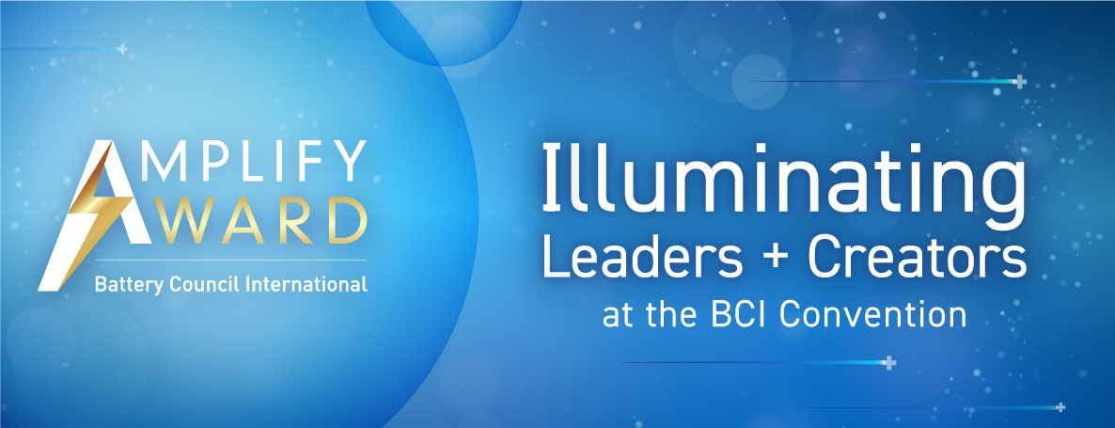

2026 BCI Amplify Award Submission Form
Thank you for your interest in the annual BCI Amplify Award! This award recognizes highly effective and top-rated campaigns, programs, or communications that serve to inform, educate, and promote the battery industry.
There are two separate categories of the Amplify Award. Companies can enter a single submission for both categories if they wish, or separate entries if that is preferable.
Campaigns focused on a wide range of energy storage solutions, battery chemistries, services and applications are eligible for the Amplify Award for Product Marketing.
The Amplify Award for Industry Leadership recognizes marketing campaigns that help raise awareness around the work of the association that is supported by the BCI members, the association’s core values, and the positive influence of the energy storage industry.
All submissions must represent campaigns that were active after Jan. 1, 2025.
For additional information and examples of prior winners, please visit batterycouncil.org/about/amplify-award/

Contact information and submission details
To make the submission process as simple as possible, BCI will work directly with you to obtain all files in whatever form works best for your organization.
To begin your submission process, simply fill out this Word document, then email it to Katie Raymond at kraymond@batterycouncil.org and Jeff Reeves at jreeves@batterycouncil.org. We will then work with you directly to ensure your relevant files are received. BCI accommodates Dropbox, Sharepoint, WeTransfer, and a host of other file sharing services. Just let us know what you prefer.

Submission details
Please fill out the following form with as much information as possible to help our judges make their selection. If you only wish to enter one category, please ignore or delete the text from the other award.

Amplify Award for Product Marketing – Energy storage product campaigns, judged on marketing techniques including innovation in messaging, uniqueness, clarity, and overall design/aesthetic.

- Innovation – Please explain how the campaign effectively raises awareness for new products, services or cutting-edge applications.

- Uniqueness – Please explain how the campaign demonstrates a high level of creativity vs. other efforts in the marketplace.

- Clarity – Please explain how the campaign is noteworthy, engaging, or makes technically complex features easy to understand.

- Design/Aesthetic – Please provide additional detail on the campaign's visual appeal or other effective design components. Please provide any additional commentary to assist the judges in their decision. Design often speaks for itself, but statistics or color on audience, reach and execution are particularly helpful.

- Overall reach and execution – Please provide additional detail that indicates the campaign's potential audience and success reaching that audience.

- Please provide any additional commentary to assist the judges in their decision, if you feel it is necessary.

Amplify Award for Industry Leadership - Marketing campaigns for a product, company or initiative that raises awareness of the core values shared by BCI and the battery industry including essentiality, innovation, sustainability, and safety.

- Core values – Please explain how the campaign effectively raises awareness for at least one of BCI’s core values including essentiality, innovation, sustainability, safety.

- Uniqueness – Please explain how the campaign demonstrates a high level of creativity vs. other efforts in the marketplace.

- Clarity – Please explain how the campaign is noteworthy, engaging, or makes technically complex features easy to understand.

- Design/Aesthetic – Please provide additional detail on the campaign's visual appeal or other effective design components.

- Overall reach and execution – Please provide additional detail that indicates the campaign's potential audience and success reaching that audience.

- Please provide any additional commentary to assist the judges in their decision, if you feel it is necessary.

